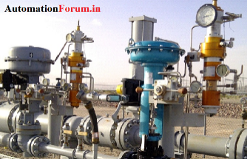
Control valve Maintenance Checklist

Date:
Valve type: |  | Tag no:
Size & Class: |  | Manufacturer:
Tag Number: |  | Location:

Visual Inspection:
SL.no | Check | Done | Comment
1. | Check for Name plate | ☐
2. | Check for Tag no. on the valve | ☐
3. | Check for leaks at Valve hand | ☐
4. | Check leaks in flanges | ☐
5. | Check for body leak | ☐
6. | Check that the yoke clamp bolt is not loose | ☐
7. | Air leakage from pneumatic components | ☐
8. | Actuator shaft condition | ☐
9. | Air leakage from pneumatic components | ☐
10. | Condition of the valve stem and stem nut connector | ☐

Maintenance check:
Sl.no | Check |  | Done | Comment
1. | Seal & Seat | Seat leakage test at high pressure (Annually) | ☐
2. |  | Check the rubber seals for cracking or for other sign of deterioration | ☐
3. |  | Check for seal retainers and bolts | ☐
4. |  | Check seal seats, wallplates, gate sills | ☐
5. | Valve body | Check for corrosion, crack and damage | ☐
6. |  | Check interior for cavitation errosion | ☐
7. |  | Check for lubrication to bearing and oil level of gear box | ☐
8. | Check & Replace | Check stem & trim condition | ☐
9. |  | Replace soft goods, for example, gaskets, packing, diaphragms, seals | ☐
10. |  | Bearing surfaces | ☐
11. |  | Bolting or stud holes | ☐
12. |  | Valve Stem | ☐
13. |  | Electrical connections | ☐
14. |  | Stuffing box | ☐
15. |  | Check the actuation performance | ☐
16. |  | Piping system: Remove corrosion | ☐

Name: Designation: Sign:

